DARLING DOWNS RESIDENTS ASSOCIATION (DDRA)  MEMBERSHIP APPLICATION FORM  (ONLINE VERSION) | 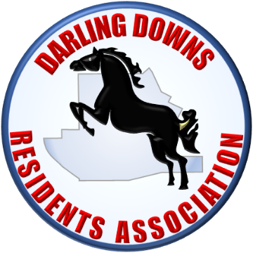
Instructions for filling out and submitting this form are provided on Page 2.
Residential Address
Postal Address (if different)
First Name | Family Name |  | Date of Birth | Email Address | Home Phone Number | Mobile Number
The submission of the information on this application attests that:
- the information provided is true and accurate;
- all prospective members listed on this form can be authorised as members in accordance with the DDRA Rules of Association;
- the persons nominated for membership will comply with the DDRA Rules of Association
- persons named on this form will advise the DDRA if there are significant changes to the information provided.
INSTRUCTIONS FOR USING THE MEMBERSHIP FORM
- This word document is designed to support filling in the required information within the document online.
- It is best to make a copy of this file on your computer and then click into the cells where you want to insert and type your details.
- Firstly, insert the residential address at which the proposed members are living. Each of the people listed in the application must be living at this address.
- If you would prefer notifications to be provided to a different postal address, please insert that information in the second row.
- In the following rows of the table, please insert the information required in each column for each proposed member. There must be at least one phone number and email address for each person, so members can be contacted effectively. Where there is only one email address or phone number for each residence, please insert the same phone numbers/email addresses for each proposed member.
- In the third column of the nominated members’ information section, please insert the person’s date of birth. This information is required to confirm whether the nominee is an adult (18 years of age or over).
This is required, as only adults can become Ordinary Members. Children will also be able to gain the benefits of membership as Associate Members or Honorary Associates.

Please note: Darling Downs Residents Association Inc. (DDRA) is committed to ensuring that your privacy is protected. Click here to review the DDRA Privacy Policy.
SUBMITTING THE COMPLETED FORM
- Please check the information carefully, and then:
  - if you are presenting this form as a printed copy, a person from the nominated address must sign the printed form and fill in the associated information within the address block at the bottom of this page.
  - if the form is being submitted by email, a signature is not required, but the person completing the form must fill in their full name at the bottom of the page.

- Once you have completed filling in the form, save the file on your computer.
Form can be posted or emailed.

  - The printed form can be posted to the
DDRA Secretary
Penny Ellis,
51 Kentucky Drive West, Darling Downs, 6122
or
  - email the completed form as an attachment to: penny@kea.com.au .

Should you have any queries about the process do not hesitate to contact Penny by email.

Signature (If completing a printed copy)
Full name of the person completing this form for submission

